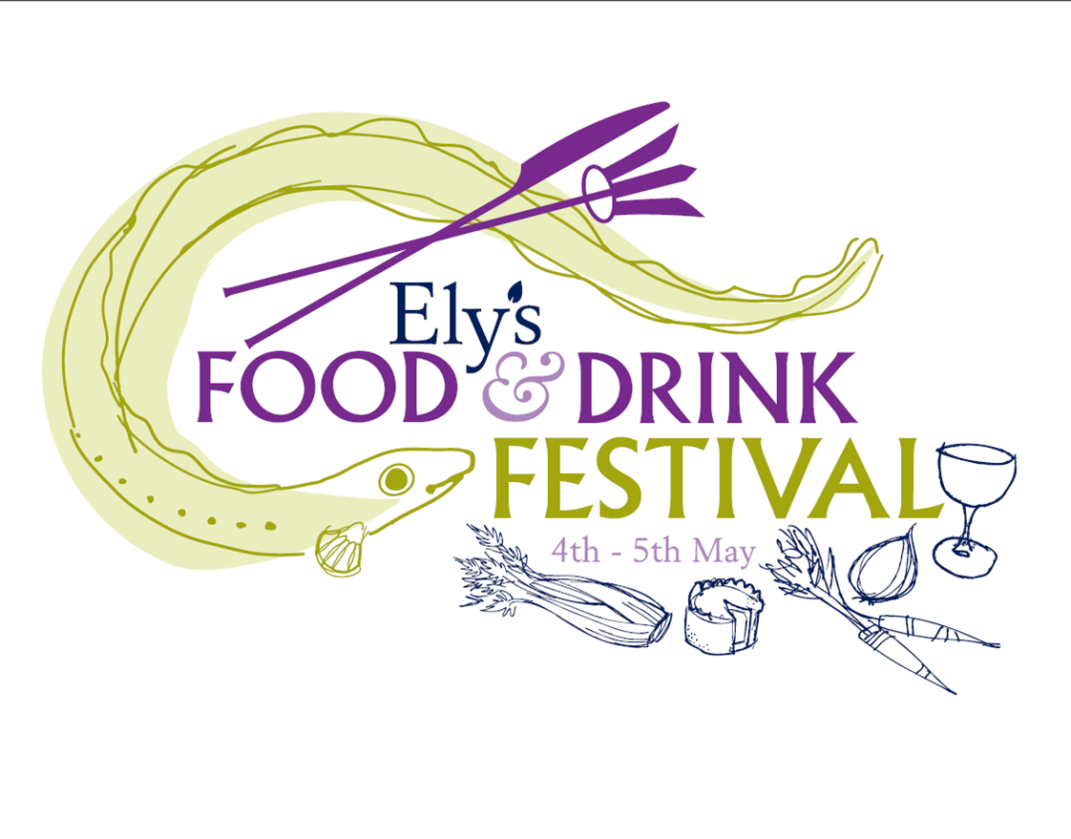

**We warmly invite you to the first Ely Food and Drink Festival located on Palace Green under the gaze of the magnificent Ely Cathedral in the heart of this historic city. The festival is part of Ely’s established Eel Festival Weekend running from 2nd to 5th May organised by the Tourism Team at East Cambridgeshire District Council.**

***We are pleased to acknowledge the support of locally based G’s Growers, producers of the finest quality salads and vegetables.***

**The Festival weekend kicks off on Friday 2nd May with the launch of the Eel Food Safari where a variety of venues will be providing eel inspired dishes and menus throughout the weekend. Saturday sees the famous Eel Day Parade – a colourful, musical procession from the City Centre to the riverside, where a host of activities are held including the World Eel Throwing Championships and the Town Crier Competition.**

**The Food Festival itself will take place on Sunday and Monday and will feature a Food Marquee, The Street Food Place and the Flower, Food and Craft Market.**

**As well as some large exhibitions from local producers, we have a fantastic line up of chef demonstrations running throughout the Festival with some well known names soon to be announced! All our key artisan, specialist food and drink traders will be housed in our large *Food Marquee* providing lots of expert advice, information and tantalising tasters. Outside, *The* *Street Food Place* allows for discovery of a wide range of expertly cooked and served food. The Festival will be supported by the well established *Flower, Food and Craft Market*, a regular feature in Ely on bank holiday weekends, now in a new location for this weekend only, showcasing some of the best local produce and crafts in the area.**

**Further entertainment will be available throughout the city on the Sunday and Monday including a Fun Fair on Ely’s Market Place and historical walks from Ely Tourist Information Centre. Supported by The Ely Gin Company, your walk ends with an opportunity to sample the wonderful flavours of Ely Gin and Taste the Spirit of the Fens!**

**For information on all these activities and many other fringe events keep checking out our Eel Festival Weekend page at** [**www.visitely.org.uk**](http://www.visitely.org.uk)**.**

**To confirm your interest in attending our Food and Drink Festival, please complete and return the Application Form. We look forward to you joining us!**

**Tracey**

**On behalf of the Tourism Team at East Cambridgeshire District Council**

**Ely Tourist Information Centre**

**Oliver Cromwell’s House, 29 St Mary’s Street, Ely,**

**Cambridgeshire. CB7 5ZQ**

**Tel: 01353 662062 e-mail:** [**tic@eastcambs.gov.uk**](mailto:tic@eastcambs.gov.uk)



**Twitter @visitely** [**www.visitely.org.uk**](http://www.visitely.org.uk)

** **

**ELY FOOD AND DRINK FESTIVAL - 4th to 5th MAY 2014**

**APPLICATION FORM**

**Name Trading Name**

**Address Tel**

**Mobile**

**E-mail**

**Postcode Web Address**

**Your Product**

**Please give a full description of all stock you will be displaying/selling and supply photographs/web links where possible. You will not be permitted to sell items not listed here.**

|  |  |  |
| --- | --- | --- |
| **Zone** | **Space** | **Cost for 2 days** |
| **Space within the Food Marquee (inc table and 1 chair)** | **6ft** | **£120** |
| **Flower, Food and Craft Market**  **(own stall/pop-ups)**  **Additional space at £5 per m2** | **3 x 3 m** | **£80** |
| **Street Food Place**  **(own trailers or pop-ups)**  **Additional space at £10 per m2** | **5 x 3 m** | **£200** |

**Are you intending to use electrical items? YES/NO**

**Please note that if power can be supplied to your stall, a maximum wattage of 120 watts will be available per single pitch unless agreed by special arrangement.**

**For FOOD VENDORS Only:**

**With which local authority is your business registered?**

**When was it last inspected?**

**Are staff trained in food hygiene?**

**If handling open foods, do you have hand washing facilities/equipment?**

**N.B. It is the responsibility of the stall holder to ensure all waste is removed at the end of each day.**

**Please supply a copy of your latest electrical safety certificate/ gas certificate, risk assessment, Public Liability Insurance where applicable.**

**Please return this form with your cheque made payable to “East Cambridgeshire District Council” along with all relevant in-date paperwork to:**

**Tracey Harding, Ely Tourist Information Centre, Oliver Cromwell’s House, 29 St Mary’s Street, Ely, Cambs. CB7 4HF.**

[**tracey.harding@eastcambs.gov.uk**](mailto:tracey.harding@eastcambs.gov.uk) **01353 662062 Twitter @visitely**

**Your application will be confirmed as soon as possible. In the event that we are unable to accept your application due to duplication, unsuitability or lack of space available we will of course return your payment.**